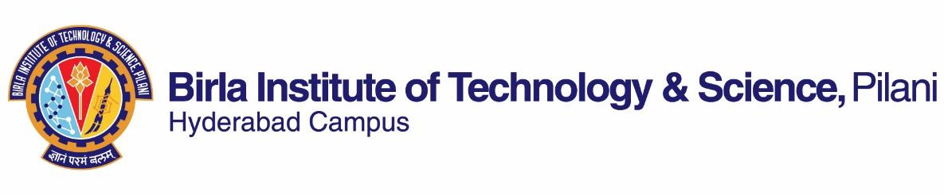

**FIRST SEMESTER 2019-2020**

# Course Handout Part II

01-08-2019

In addition to part-I (General Handout for all courses appended to the time table) this portion gives further specific details regarding the course.

*Course No.* : BITS F214

## Course Title : Science Technology and Modernity

## Instructor-in-Charge : Aswathy Raveendran

**Scope and Objective of the Course:**

The course intends to analyse the interrelationship between science, technology and modern society; forms in which beliefs and values of a modern society shape sciences and technologies; forms in which scientific discoveries and technological developments influence and shape modern societies. It looks into the Scientific Revolution and the emergence of modernity as a social condition; Enlightenment promise of progress within the economic system of capitalism. Further it discusses some critiques of the received view; recent phase of capitalism and the role of technology in globalization.

**Textbooks:**

1. McCllelan III, J.E. and Dorn, H. 2006. *Science and Technology in World History*, Second Edition, Maryland: John Hopkin University Press

**Reference books**

1. Akubue, A. (2000). Appropriate technology for socioeconomic development in third world countries. The Journal of Technology Studies, 26(1), 33-43.
2. Chadha, G. (2005). Towards an informed science criticism: The debate on science in postcolonial India. In K. Ganesh, & U. Thakkar (Eds), Culture and the making of identity in contemporary India (pp. 247–258). New Delhi: SAGE Publications.
3. Godfrey-Smith, P. (2003). *Theory and reality: An introduction to the philosophy of science*. University of Chicago Press (chapters 5, 6 and 8).
4. Kitcher, P. (2003). Science, truth, and democracy. Oxford University Press. (chapter 1, Unacceptable images).
5. Layton, E. (1971). Mirror-image twins: The communities of science and technology in 19th-century America. *Technology and Culture*, *12*(4), 562-580.
6. Nandy, A. (1989). Science as a Reason of State. *Science as Culture*, *1*(7), 69-83.
7. Sismondo, S. (2010). An introduction to science and technology studies (Vol. 1). Chichester: Wiley-Blackwell. (Chapter 9)
8. Raina, D. (2006). Towards a global history of science, its history and theory of history. In M. Dutta and S. Nevatia (Eds.) Sites and practices, an exercise in cultural pedagogy (232-242). Mumbai: Majlis.
9. Samir Okasha (2003). Philosophy of science: a short introduction. (chapter 1- What is science?)
10. Winner, L. (1980). Do artifacts have politics? *Daedalus*, 121-136.

**Course Plan:**

|  |  |  |  |
| --- | --- | --- | --- |
| **Lecture No.** | **Learning objectives** | **Topics to be covered** | **Chapter in the Textbook** |
| 1-3  4-10 | To appreciate the interrelationships between science, technology and society | -Role of science in a democratic society  - Nature of science and technology (focus on philosophical positions on science and technology) | RM3, RM4, RM7, RM9 |
| 11-14  15-20 | To historically situate the emergence of modern western science in the global context. | -Science and technology in ancient and medieval civilizations  -Scientific Revolution and the emergence of modernity as a social condition; Enlightenment promise of progress within economic system of capitalism | Brief Summary of TB Part I, II, III (excluding chapter 9), RM 8 |
| 21-24  25-27  28-30 | To explore the debates on Science, technology and modernity in the Indian context. | - Scientific imagination in postcolonial India  -Ideological positions on science (liberal, Marxist and postmodern positions)  -Science as a reason of Indian state  -Scientific temper and modernity | RM 2, 6 |
| 30-35  36-40 | To critically analyze the role of technology within modernity and globalization | -Science technology and industrial civilization  -Nature and politics of technology | TB Part IV (chapters 14,17, 20) RM 1, RM 5 RM 7, RM 10 |

NOTE: In addition to or instead of the textbook and reference material mentioned above, based on perceived need, students may be required to go through reference material made available at various stages of the course.

**Evaluation Scheme:**

|  |  |  |  |  |
| --- | --- | --- | --- | --- |
| **Component** | **Duration** | **Weightage (%)** | **Date & Time** | **Nature of Component** |
| Assignment 1 | NA | 15 | - | open |
| Mid semester examination | 90 minutes | 30 | 3/10, 1.30 -- 3.00 PM | closed |
| Assignment 2 | NA | 15 | - | open |
| Comprehensive Examination | 3 hours | 40 | 10/12 FN | Closed |

**Chamber Consultation Hour:** To be announced in class

**Notices:** Will be put up on CMS

**Make-up Policy:** Make ups will be granted only to exceptionally deserving candidates.

**Academic Honesty and Integrity Policy**:

Academic honesty and integrity are to be maintained by all the students throughout the semester and no type of academic dishonesty is acceptable.

**Aswathy Raveendran**

**INSTRUCTOR-IN-CHARGE**